Did you know…the MDoutlook ThoughLeader Intelligence Platform updates a physician’s clinical trials and publications in real-time? When viewing a physician’s profile, scroll to the bottom to view the feed, and gain relevant insight into recent contributions a physician has made toward medical data.

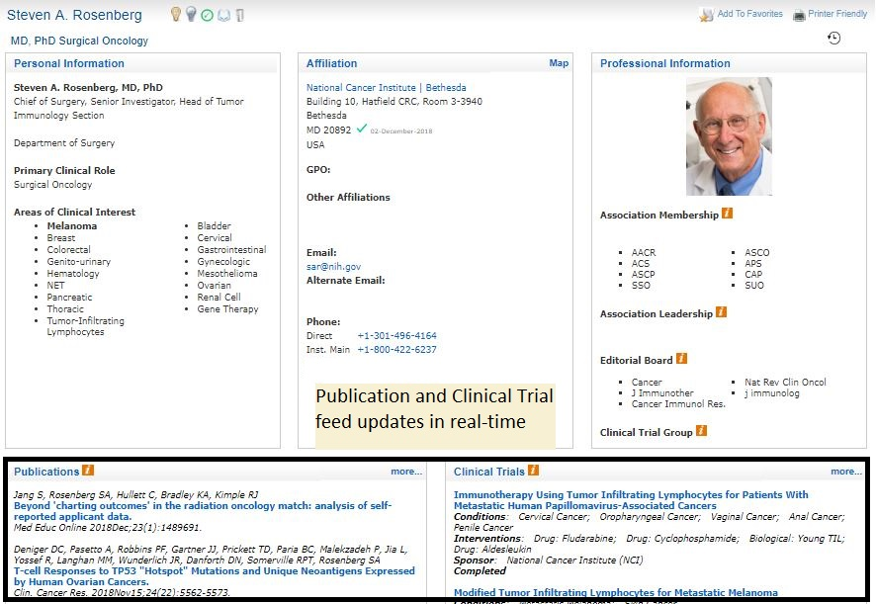
As a reminder, your MDoutlook ThoughtLeader Intelligence portal access provides you with the following customized intelligence that is presented to:
- Cancer ThoughtLeaders in-depth profiles - contact information, academic position/institution affiliation, association/cooperative group affiliation, leadership and social media profile, network mapping (if available), real-time publication/investigator activity and system analytics, and peer nomination influence heat maps and directories
- Institutions’ names, contact information, direct links to their main web site and cancer centers web site, as well as a directory of affiliated ThoughtLeaders and treaters
- Validated Cancer treaters – with the much of the above information
This real-time data is culminated into dashboards and directories that includes overall, authorship, investigator, and leadership rankings as well as peer nominating for ThoughtLeaders, treaters, and affiliated institutions.
Our clients, who are in the forefront of innovation, gain insights into the landscape of ThoughtLeaders to support future activities such as the planning of clinical trials, disease state evaluation, advisory boards, publication planning, and more.
We welcome your feedback on this new feature and/or any insights on how we may improve your user experience. We also appreciate you as a subscriber and anticipate working with you on your oncology insights and physician intelligence needs on an ongoing basis.

